**ASSOCIATIONS ACT, 2022**

*(Act 8 of 2022)*

**ARRANGEMENT OF SECTIONS**

# PART I - PRELIMINARY Sections

1. Short title
2. Interpretation

# PART II - REGISTRATION OF ASSOCIATIONS

1. Application for registration
2. Electronic mode of application for registration
3. Refusal to register
4. Identical or deceptive similarity of name not allowed
5. Incorporation: Registration essential

# PART III - RULES OF ASSOCIATIONS

1. Rules
2. Membership of minors
3. Rights of members
4. Inspection of books
5. Power of member to dispose of sums payable at his or her death by nomination
6. Sureties
7. Rules to be binding
8. Secretary to make returns
9. Information to the public

# PART IV - CANCELLATION, AMALGAMATION AND WINDING UP OF ASSOCIATIONS

1. Cancellation of registration
2. Voluntary dissolution
3. Amalgamation
4. Inquiry into affairs and conduct of association
5. Power of the Registrar to call for production of books, accounts etc 22. Winding up of affairs of association

*Supplement to Official Gazette*

# PART V - ADMINISTRATIVE PROVISIONS

1. Appointment of Registrar
2. Secretary
3. Executive committee
4. Contribution
5. Application of funds
6. Records and accounts
7. Audit
8. Annual general meeting
9. Register of members and records

# PART VI - MISCELLANEOUS

1. Appeals
2. Obligations of associations financed from Consolidated Fund
3. Registrar's certificate to be evidence
4. Certificate of current standing
5. Guidelines and practice directions
6. Memorandum of understanding
7. Exemptions
8. Offences and penalties
9. Administrative sanctions by Registrar
10. Compounding of offences
11. Regulations
12. Amendment of schedules
13. Repeal and savings
14. Transitional provisions



# ASSOCIATIONS ACT, 2022

*(Act 8 of 2022)*

*I assent*

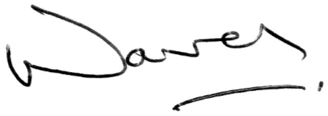 Wavel Ramkalawan

President

*28th  April, 2022*

**AN ACT** TO PROVIDE FOR THE REGISTRATION AND REGULATION OF ASSOCIATIONS, TO REPEAL THE REGISTRATION OF ASSOCIATIONS ACT, CAP 201, AND TO PROVIDE FOR OTHER RELATED MATTERS.

**ENACTED** by the President and the National Assembly.

# PART I - PRELIMINARY Short title

**1.** This Act may be cited as the Associations Act, 2022 and shall come into operation on such date as the Minister may, by notice published in the Gazette appoint.

*Supplement to Official Gazette*

# Interpretation

**2.** In this Act, unless the context otherwise requires —

“accounting period” in relation to a registered association means the period specified in its rules, in respect of which a statement of receipts and payments is to be prepared;

“association” means 5 or more persons having agreed to come together under a formal structure for a common purpose other than that of pecuniary gain to its members, but does not include a political party;

“auditor” means a person appointed as such at the annual general meeting of an association;

“charitable organisation” means an organisation with the purpose of benefitting the general public;

“Court” means the Supreme Court;

“executive committee” means the executive committee of an association, appointed under section 25;

“founder” means a person or persons who has or have undertaken some or all of the formational work needed to create an association, and who endows or endow the association with

its initial assets;

“foreign association” means an association formed outside Seychelles or in Seychelles, where at least one member is not a citizen of Seychelles ;

“member” means a member of an association;

“Minister” means the Minister responsible for legal affairs;

“office” in relation to an association means the registered office of the association;

“officer” means a person appointed as chairperson, vicechairperson, treasurer, secretary or any other member of the executive committee or an auditor of an association;

“register” means the register to be kept under section 31;

“registered ” means registered under this Act;

“Registrar” means the Registrar of associations appointed under section 23;

“revenue” means the gross receipts of a registered association;

“secretary” means the secretary of an association residing in Seychelles; and includes —

1. a person performing the duties of secretary; and
2. in the case of a foreign association, a person appointed specifically to perform duties of secretary;

“umbrella association” means an association formed by two or more associations registered under this Act, for the purpose of providing a common platform to represent them or to facilitate the exchange of information among them or to adopt and enforce standards of conduct among them or for any other lawful purpose; and

“working day” means a day other than a Saturday, Sunday or public holiday.

**PART II - REGISTRATION OF ASSOCIATIONS**

# Application for registration

**3.**(1) The proposed secretary of an association seeking registration under this Act shall make an application in writing to the Registrar not later than 3 months from the date of the first meeting at which the formation of the association and its rules were approved.

*Supplement to Official Gazette*

1. An application made under subsection (1) shall state the name, registered office, place of business and objects of the association, and shall be accompanied by certified copies of the following —
   1. the names, occupations, registered office, addresses, nationalities and documents of proof of identity of the officers, members and where necessary, of the founder or co-founders, of the association for the time being;
   2. the resolution of the members of the association appointing the officers;
   3. a copy of the minutes of proceedings of the meeting at which the rules of the association were approved;
   4. the rules of the association; and
   5. such other information in respect of the association as the Registrar may require.
2. A foreign association seeking registration shall, in addition to the requirements under subsection (2), furnish the Registrar with the following —
   1. the names and address of the person authorised to represent the foreign association in Seychelles;
   2. the names and address of the secretary of the association residing in Seychelles;
   3. the registered office of the association in Seychelles;
   4. the nature of the activity in which the foreign association intends to engage in Seychelles; and
   5. such other information or documents relating to paragraphs (a) to (d) in respect of the association as the Registrar may require.
3. In respect of a foreign association, the Registrar may request information and documents relating to the type and sources of funds of the association, which shall be kept by the Registrar and shall be accessible only by the relevant authorities or interested parties as may be determined by the Registrar.
4. The Registrar may, in considering an application under this section, consult any relevant public body or foreign authority.
5. Upon being satisfied that subsections (1), (2), (3) and (4) have been complied with and that there is no objection under subsection (5), the Registrar may —
   1. register the association by entering its name in the register and deliver to the applicant a certificate in the form set out in Schedule A;
   2. request as a condition precedent to registration that the books of the association be kept in English and that any alteration which, in his or her opinion, is necessary be made to the rules of the association; or
   3. refuse registration.
6. An association that has been registered remains registered until —
   1. its registration is cancelled under this Act;
   2. the association is voluntarily deregistered; or
   3. the association is wound up or dissolved.
7. For the purposes of this section and section 16(3), the Registrar shall maintain a register of all associations registered or deemed to be registered under this Act or, immediately upon the coming into force of this Act were in operation under the repealed Act, in such form as the Registrar may determine.
8. The register may be maintained in an electronic data storage retrieval system or such other form as the Registrar may determine, but shall be capable of producing copies in paper form if required.

*Supplement to Official Gazette*

1. The register maintained by the Registrar under subsection (1) shall contain in respect of every association —
   1. the name and any former name of that association;
   2. the registration number and date of registration;
   3. the date of registration;
   4. the address of the registered office;
   5. the date on which the name of the association was struck off the register, where applicable;
   6. the date on which the name of the association was restored to the register, where applicable;
   7. the name and address of the members of the executive committee and any former members of the executive committee;
   8. the name and address of the secretary and former secretary; and
   9. any other information required by the Registrar.
2. An association kept on the register of associations under subsection (8) shall in each year, pay an annual fee of SCR 200 to the Registrar by the 31st December of each year.
3. If an association fails to pay the annual fee payable in accordance with subsection (11), the association in default is liable to pay, in addition to the annual fee, an administrative penalty of SCR100 to the Registrar for every month or part of that month that the default continues.

# Electronic mode of application for registration

**4.**(1)An application for the registration of an association may be made by electronic means, by the secretary, through —

1. filing of the standard online documents as may be specified by the Registrar through regulations and complying with other requirements of this Act in respect of registration of associations; or
2. affixing a digital signature and transmitting, by electronic means, the application for registration to the Registrar and complying with paragraph (a) and the requirements of the Electronic Transactions Act, 2001 with regard to digital signatures.

(2) This section shall, with necessary modifications as may be specified by the Registrar through regulations, apply to an application for registration filed by a foreign association.

# Refusal to register

**5.**(1) The Registrar may refuse to register an association under this Act —

1. where the objectives of the association as specified in its constitution are in contravention of the laws of Seychelles or in the opinion of the Registrar the activities and objectives of the association are likely to be contrary to the national interest or a threat to the public interest or public order;
2. where the application for registration does not comply with the requirements of this Act; or
3. where the applicant has given false or misleading information in any material particular.
4. Where the Registrar refuses to register an association under subsection (1), the Registrar shall inform the applicant in writing of the reasons for his or her refusal within thirty days from the date of the refusal.
5. A person or an association aggrieved by the decision of the

Registrar under subsection (1) may, within two months of the date of the

Registrar's letter under subsection (2), appeal to the Minister against that decision.

# Identical or deceptive similarity of name not allowed

**6.**(1) No association shall be registered under a name —

1. identical with that under which any other existing association is registered or so nearly resembling such name as to be likely, in the opinion of the Registrar, to deceive the public or the members as to its nature or its identity;
2. which in the opinion of the Registrar, suggests or is calculated to suggest the patronage of or any connection with Seychelles or the Government of Seychelles or with any other country or the Government of that country unless otherwise approved by the Registrar; and
3. which is indecent, offensive or, in the opinion of the Registrar is otherwise objectionable or misleading or is likely to being confused with another association.
4. No association shall change its name without the prior approval of the Registrar.
5. A person may apply to the Registrar for the reservation of a name for an association set out in the application as —
   1. the name of an intended association; or
   2. the name to which an existing association proposes to change its name.
6. The Registrar may reserve a name for an association if the Registrar is satisfied as to the *bona fides* of the application and that the proposed name by which the intended association or existing association could be registered is not such as to contravene this Act or any other law.
7. The Registrar shall, on approving a reservation of a name in accordance with subsection (4), notify the applicant, in writing, and shall register the name as reserved for a period of 30 days from the date of the notice.
8. At any time while the name is so reserved in accordance with subsection (4) a person may make an application to the Registrar for an extension of the period, and if the Registrar is satisfied as to the *bona fides* of the application, the Registrar may grant an extension of the reservation of the name for a period not exceeding 5 months from the date of the expiration of the 30 day period under subsection (5).
9. For the avoidance of doubt, a name for an association shall not be reserved for a period exceeding 6 months.
10. During the period in which a name is reserved, no association, other than the intended association or an existing association in respect of which the name is reserved may be registered under this Act, whether originally or on change of name, under the reserved name.
11. An association shall normally contain in its name the word “association”.
12. The Minister may prescribe fees and forms for the reservation of a name for an association under this section.

# Incorporation: Registration essential

**7.**(1) An association registered under this Act shall be a body corporate having perpetual succession and a common seal, and power in its corporate name to —

1. acquire, hold, and dispose of property, movable or immovable;
2. sue and be sued in its corporate name; and
3. generally to do all such acts and things as bodies corporate may do and perform.

(2) Service of process on the secretary of the association or at the registered office, or principal place of business shall be deemed to be service on the association.

# PART III - RULES OF ASSOCIATIONS Rules

**8.**(1) The rules of every association seeking registration under this Act shall contain the several matters specified in Schedule B, and shall, on the association being registered, become the rules of the registered association.

1. An association may amend its rules at a general meeting convened in that behalf, where not less than three-fifths of the total number of members of the association are present in person or by proxy.
2. Two-thirds of the number of members present in person or by proxy at a meeting held under subsection (2) shall be sufficient to amend the rules of the association.
3. An amendment of the rules of an association shall have no effect unless it is approved by the Registrar, in the form set out in Schedule C.
4. An application for the registration of an amendment to the rules of an association shall be signed by the secretary and shall be accompanied by —
   1. two copies of the proposed amendments to the rules; and
   2. a certified copy of the minutes of the proceedings of the general meeting at which the special resolution to amend the rules was passed.
5. A copy of the rules so approved shall be filed with the Registrar.

# Membership of minors

**9.**(1) The rules of a registered association may provide for the admission of a person under eighteen years of age as a member.

1. Anything to the contrary in any enactment notwithstanding, any such member may, if he or she is over fifteen years of age by himself or herself, and if he or she is under that age by his or her parent or guardian, execute all instruments and give all acquaintances necessary to be executed or given under the rules.
2. For the avoidance of any doubt, a member below the age of fifteen years shall not be an officer of the association.

# Rights of members

**10.**(1) Every registered association shall, upon request by a member, deliver to the member a copy of the rules of the association in paper or digital form.

(2) Every registered association shall supply gratuitously to every member or person having an interest in its funds, on his or her application, either —

1. a copy of the last annual return of the association;
2. a copy of a balance sheet or other document duly audited containing the same particulars regarding the receipts and expenditure, funds and effects of the association which are contained in the annual return; or
3. a copy of all receipts, expenditure and banking transactions.

# Inspection of books

**11.**  A member or person having an interest in the funds of a registered association may inspect the books at all reasonable times at the registered office of the association, except that the person shall not, unless he or she is an officer of the association, or is specially authorized by a resolution of the association to do so, have the right to inspect the loan or debit account of any other member without the written consent of that member.

# Power of member to dispose of sums payable at his or her death by nomination

**12.**(1) A member of a registered association, not being under the age of eighteen years may, by writing under his or her hand delivered at or sent to the registered office of the association, or made in a book kept at that office, nominate a person to whom any sum of money payable by the association upon the death of that member, shall be paid.

1. A person nominated under subsection (1) shall not be an officer or employee of the association, unless that officer or employee is the spouse, father, mother, child, brother, sister, nephew or niece of the nominator.
2. A nomination made under subsection (1) may be revoked and varied in writing by a document under the hand of the nominator, delivered, sent, or made under that subsection.

# Sureties

**13.**(1) The rules of an association may require any officer who is appointed to an office involving the receipt or management of monies collected on behalf of the association to become bound with one or more sureties for the just execution of such office, and for rendering a true account according to the rules and regulations of the association, before the officer takes up the duties devolving upon the office.

(2) The bonds taken under subsection (1) shall be filed with the Registrar without payment of a fee or stamp duty, and in case of forfeiture, shall be handed over to the treasurer or other appropriate officer of the association for such suitable legal action as may be deemed advisable.

# Rules to be binding

**14.**(1) The rules of an association shall bind the association and every member or person claiming through such member to the same extent as if such member or person has subscribed his or her name to the rules.

(2) No person shall be liable for debts contracted by an association after he or she has ceased to be a member of the association, unless the debt was contracted during the period when he or she was still a member of the association.

# Secretary to make returns

**15.**(1) The secretary of every registered association shall, before the thirty-first day of July in each year, or when and as often as so requested by the Registrar, furnish to the Registrar a return of the names and addresses of the officers of the association and an audited account of the annual revenue and expenditure, and of the assets and liabilities, of the association in such form as the Registrar may require:

1. Any change occurring in the place of office or among the officers of a registered association shall be notified to the Registrar within fourteen days of such change.
2. A secretary who fails to comply with sub-section (1) or (2) commits an offence and shall, on conviction be liable to a fine not exceeding SCR500 for the first 60 days or part of those days, and SCR 100 for every day for the next 30 succeeding days or part of them, during which the noncompliance continues.

# Information to the public

**16.**(1) Any person shall have a right to inspect the register and obtain a certified copy of any document of a registered association from the Registrar, subject to the payment of such fee as the Minister may prescribe.

1. The Registrar shall publish in the Gazette or electronically in any form that is accessible to the public, the following documents —
   1. every newly registered association, within fourteen days of its registration; and
   2. every association struck off the register, within fourteen days of its striking off.
2. As soon as practicable after 1 January in every year, the Registrar shall publish in the *Gazette* a list of all associations registered or deemed registered under this Act and maintained on the register in accordance with section 3(8).
3. The Registrar shall preserve and have custody, in original or other form of all reports and other documents submitted to the Registrar by a registered association under this Act.
4. The Minister may prescribe other circumstances or manner in which a member of the public may have access to documents preserved under this Act.

**PART IV - CANCELLATION, AMALGAMATION AND WINDING UP OF ASSOCIATIONS**

# Cancellation of registration

**17.**(1) The Registrar may cancel the registration of a registered association on the grounds that —

1. the registration was obtained by fraud or misrepresentation;
2. the association has engaged or is about to engage in activities likely to cause a serious threat to public security or public order;
3. the association has contravened its rules or this Act, or the Anti-money Laundering and Countering the Financing of Terrorism Act, the Prevention of Terrorism Act or the Beneficial Ownership Act, and has persisted in its default after the Registrar has given it written notice specifying the default and fixing a time which shall not be less than twenty one days for remedying the default, and that time has expired;
4. the association has in any way misapplied its funds;
5. the Registrar has reasonable cause to believe that the association is not carrying on its functions or is not in operation; or
6. the association has ceased to function.

1. Where the Registrar is satisfied that the registration of an association should be cancelled, the Registrar shall give notice to the secretary, of the Registrar's intention to cancel the registration of the association and of the grounds for his or her decision.
2. Notwithstanding subsection (2), the Registrar may inquire from relevant authorities to ascertain whether there exists any objection or reasonable ground to prevent the striking off of an association or to suspend the striking off until a later date.
3. A notice under subsection (2) shall be given —
   1. by registered post; or
   2. by service on the secretary or at the registered office of the association or, in the case of a foreign association, at its principal office in Seychelles;
   3. where the secretary of the association cannot be found or the registered office, or the principal office is not known, by publication of the notice in the *Gazette* or a daily newspaper.
4. A notice given under subsection (2), shall serve as a notice on the association, its members and officers not to deal with the assets of the association unless otherwise approved or directed by the Registrar.
5. The Registrar may prescribe the procedures in relation to ascertaining the debts, liabilities and assets of the association, to allow the proper dealing with the assets of the association under subsections (4) and (8)
6. Any officer who fails to comply with any request for information under any procedures prescribed under this section commits an offence and shall be liable on conviction to a fine of level 2 on the standard scale or to imprisonment not exceeding 3 years or to both.
7. An association may, not later than twenty-one working days after the date of a notice under subsection (2), appeal to the court against the decision of the Registrar, and, on any such appeal the Judge may make such order as the Judge deems fit.
8. The registration of an association shall be cancelled and the association shall be struck off the register or wound up by the Registrar and struck off the register in accordance with section 22 —
   1. where no appeal has been lodged under subsection (7), not later than sixty days after the date of a notice under subsection (2);
   2. where an appeal has been lodged under subsection (7) and the appeal has been dismissed, not later than 30 days after the date of the dismissal of the appeal.
9. Upon the striking of an association off the register, all the property of that association shall become vested in the Registrar and an administrator shall be appointed by the Minister for the purpose of advising the Registrar how such property shall be used towards meeting, as far as possible, all the debts and liabilities of the association, and where all the assets are not disposed off, to which association or charity such assets are to be vested.
10. The Registrar shall subsequent to subsection (9) recommend to the Minister to which association or charity the un disposed assets shall be vested as the Minister may determine.
11. A person appointed by the Minister under subsection (10) shall submit a report to the Registrar.
12. .Any cost incurred by the Registrar under this section shall be borne by the association and may be paid out from the proceeds of any disposal of the property.
13. Any person who deals with the property of an association without the approval of the administrator under subsection (9) commits an offence and shall be liable on conviction to a fine of level 2 on the standard scale or to imprisonment not exceeding 3 years or to both.

# Voluntary dissolution

**18.**(1) The Registrar may cancel the registration of an association upon an application made by the association or any officer for voluntary dissolution, on the grounds that the association has ceased to function, subject to the submission of the relevant application, information and documents as the Registrar may determine, provided there is no objection of the striking off from other relevant authorities

1. Where the Registrar is satisfied that the registration of anassociation should be cancelled, the Registrar shall publish a notice in the *Gazette*, electronically, or in any other form that is accessible to the public.
2. An officer or any interested person may lodge an opposition with the Registrar against the voluntary dissolution of an association.
3. An opposition under subsection (3) shall be made in writing and the Registrar may require that it be supported by an affidavit.
4. An opposition under subsection (3) shall be served on the Registrar within twenty-one days from the date of publication of the notice under subsection (2).
5. Where —
   1. no person opposes the voluntary dissolution of an association and the Registrar is satisfied that the association be dissolved; or
   2. the Registrar is satisfied that the association be dissolved,

the Registrar shall cancel the registration of the association and shall strike it off the register and publish a notice of the dissolution in the *Gazette*.

1. The association may, before the period specified in the notice under subsection (2), by special resolution designate to the Registrar, a registered association to which any remaining property of the association after the settling of all its debts and obligations shall be transferred.

# Amalgamation

**19.**(1) Subject to subsections (2) and (4), two or more registered associations may amalgamate to form one association if a special resolution to that effect is approved by every registered association concerned.

1. Where two or more registered associations have resolved to amalgamate, the secretaries of the associations concerned shall, within thirty days after the last association has done so, jointly —
   1. give written notice of the amalgamation to the Registrar; and
   2. apply under section 3 for the registration of the new association formed after the amalgamation-

1. Upon receipt of a notice under subsection 2(a), the Registrar may inquire from the relevant authorities to ascertain whether there exist any objection or reasonable ground to prevent the striking off of the association.
2. Where the Registrar registers an association formed by the amalgamation of two or more registered associations, the Registrar shall cancel the registration and strike those associations off the register and shall issue the new association a certificate in the form set out in Schedule D.

1. The amalgamation shall take effect from the date of the registration of the new association under subsection (3).

# Inquiry into affairs and conduct of association

**20.**(1) The Registrar may —

1. if the Registrar has reasonable grounds to believe that any condition specified under section 17 (1) exists in relation to a registered association; or
2. upon the written application of one tenth of the members of an association,

call for all accounts and documents relating to the association, and institute an inquiry into the affairs and conduct of the association.

1. For the purposes of this section, the Registrar may summon witnesses and examine them on oath.
2. A person summoned to attend as a witness or to produce any document shall comply with the summons in the same manner as a witness is bound to comply with the summons issued by the court.
3. Any person who —
   1. without reasonable excuse, fails to appear before the Registrar when summoned or required by the Registrar;
   2. without reasonable excuse, fails to produce a document when required to do so by the Registrar; (c) gives false evidence before the Registrar,

commits an offence and shall be liable on conviction to a fine of level 2 on the standard scale or to imprisonment not exceeding six months or to both.

1. Every enactment relating to witnesses and evidence shall, subject to the other provisions of this Act, be applicable to every witness appearing, and to evidence given, before the Registrar.
2. Where at the conclusion of an inquiry the Registrar is of the opinion that the registration of an association should be cancelled, the Registrar shall proceed and cancel the registration under section 17.
3. An association aggrieved by the decision of the Registrar under this section may, not later than fourteen working days after the date of the decision under subsection (6), appeal to the court against the decision of the Registrar, and, on any such appeal the Judge may make such order as the Judge deems fit.
4. The Registrar may, with the approval of the Attorney General, appoint an officer or any other person to conduct an inquiry in any case for the purposes of subsection (1) under such terms and conditions as the Registrar may determine.
5. The Registrar may determine that the whole or any part of the expenses of or incidental to an inquiry resulting from an application made under subsection 20(1)(b), be paid or refunded by the Association and may direct the expenses be so paid or refunded.
6. The officer or other person appointed under subsection (8) shall have the same powers as the Registrar under this section for the purposes of the inquiry.
7. The officer or other person appointed by the Registrar under subsection (8) to conduct an inquiry shall provide a report of that inquiry to the Registrar with his or her conclusions.
8. The report of the inquiry, if certified or approved by the Registrar, shall be deemed to be the conclusions of the Registrar under this section.
9. A copy of the report shall, if certified by the Registrar to be a true copy, be admissible as evidence —
   1. of any fact stated in the report; or
   2. of the opinion of a person as to any matter referred to in the report,

in any legal proceedings instituted in respect of an association as a result of an inquiry under this section.

# Power of Registrar to call for production of books, accounts and other returns

**21.**(1) The Registrar may, when and as often as the Registrar may deem necessary, call upon the secretary, or treasurer or other member of the executive committee of any association, to produce to him or her or to an auditor or accountant, at such time and place as the Registrar may determine, any book or document in the custody of such secretary, treasurer or other member of the executive committee.

1. Notwithstanding the provisions of subsection (1), the Registrar shall have power to institute and conduct on-site inspections with or without notice, to enable the Registrar to ensure that a registered association is complying with this Act.
2. Any secretary, treasurer or other member of the executive committee who fails to comply with the provisions of sub-section (1) commits an offence and shall be liable on conviction, to a fine of level 1 on the standard scale and to imprisonment not exceeding three months or to both.

# Winding up of affairs of association

**22.**(1) The Minister may appoint a liquidator for the purpose of winding up and dissolving a registered association, on such terms and conditions as the Minister may specify in the letter of appointment.

1. The liquidator shall for the purposes of subsection (1) —
   1. identify and take possession of all the assets of the association;
   2. call for claims by such public notice as the liquidator deems appropriate, requiring the claims to be made to him or her within the period of not less than ninety days of the notice;
   3. apply the assets received —
      1. in satisfaction of any dues to the Government;
      2. in payment of the remuneration for the services of the liquidator; and
      3. in satisfaction of all claims admitted by the liquidator.
2. When the liquidator has complied with the provisions of subsection (2), he or she shall submit a written report of his or her conduct of the liquidation to the Registrar and, upon receipt of the report, the Registrar shall recommend to the Minister that all the assets of the association that are not disposed of shall vest in such association or charitable organisation as the Minister may determine.
3. Where the name of an association has been struck off the register by the Registrar but the association has not been wound up, any interested party may, before the expiration of 5 years from the date of cancellation, apply to the court by petition supported by an affidavit of facts to restore the association to the register.
4. Any order of the court for the restoration of the association shall comply with this Act and may be subject to such conditions that the court may find fit to impose.
5. In any such proceedings, the Registrar shall be made a party to the proceedings.

**PART V - ADMINISTRATIVE PROVISIONS**

# Appointment of Registrar

**23.**(1) The President may appoint a fit and proper person to be the Registrar of Associations for the purposes of this Act.

1. The President may appoint a public officer as Deputy Registrar and such other public officers as the President considers necessary, to assist the Registrar in the proper discharge of the functions of the Registrar.
2. The Registrar may delegate to the Deputy Registrar or such other public officer appointed under subsection (2), any of the functions of the Registrar under this Act.
3. The assignment or delegation of any function under subsection (4 shall not prevent the exercise of that function by the Registrar.
4. The Deputy Registrar or other public officer appointed under subsection (2) shall have the powers of the Registrar in respect of the delegation.

# Secretary

**24.**(1) Every registered association shall have a secretary who may be an individual, a company or body corporate, or a firm.

(2) Anything required or authorised to be done by the secretary may, if the office is vacant or there is for any other reason no secretary capable of acting, be done by any officer of the association authorised generally or specially in that behalf by the executive committee, until such time as a secretary is appointed.

# Executive committee

**25.**(1) Every association registered under this Act shall have an executive committee which shall include the members proposed and voted by the association as chairperson, vice chairperson, treasurer, secretary of the association.

1. The members of the executive committee may in accordance with the association rules, form sub committees and appoint members amongst themselves to be part of the sub committees.
2. A member proposed and voted under subsection (1) shall apply to the Registrar for approval before becoming a member of the executive committee of the association.
3. Before approving an application under subsection (3), the Registrar shall satisfy himself or herself that the proposed member understands the obligations of the respective office, possesses the relevant qualifications and experience as may be specified by the Registrar, and has satisfied all the necessary requirements under this Act.
4. With regard to the position of secretary, the Registrar shall, in addition to subsection (4), be satisfied that the applicant is a resident of Seychelles, and in the case of a company, firm, or body corporate applying to act as secretary, at least one officer of the company, firm or body corporate shall meet the requirements of subsection (4).
5. The Registrar shall prescribe the application form for the purposes of this section, which shall contain a declaration to be sworn by each applicant regarding the information and particulars provided in the application.
6. The application under subsection (6) shall in addition contain a declaration from all the members of the executive committee to the effect that they are aware of their obligations under this Act and other relevant laws.
7. An application under this section shall be subject to payment of such fee as the Minister may prescribe.
8. The Registrar may approve or decline an application under this section, or may cancel an application already approved on the grounds that the applicant did not comply with the terms and conditions of the approval issued by the Registrar, or contravened the provisions of this Act or any other relevant law.
9. No person shall be appointed as a member of the executive committee, where that person —
   1. is of unsound mind;
   2. is an undischarged bankrupt;
   3. has been removed as an officer for violation of the rules of the association or any other written law; or
   4. has been convicted of an offence involving corruption, fraud, dishonesty or moral turpitude.
10. Where a person is removed from office for a reason provided under subsection (10) or was a member of the executive committee of an association that has been cancelled under this Act, he or she shall be restricted from being appointed on the executive committee of an association for a period of not less than three years.
11. The chairperson, vice-chairperson, treasurer and secretary shall be appointed for a term of three years and shall be eligible for reappointment for one more term of three years.
12. For the avoidance of doubt, the chairperson, vice-chairperson, treasurer and secretary shall not hold office for more than 2 terms or a tenure exceeding 6 years, except where an application is made to the Registrar on exceptional grounds, for extension of the 2 terms for a further term of three years.
13. An application under subsection (13), shall be made to the Registrar in the prescribed form.
14. Any person whose application is denied or whose approval is cancelled under subsection (9) may appeal to the court under section 32.
15. Where a member of the executive committee resigns or is removed from office by the association, the association shall, within 14 days of the date of notice of resignation or removal, notify the Registrar, and seek the approval of the Registrar for the resignation or removal of the member.
16. Where the Registrar approves a resignation or removal of a member of the executive committee under subsection (14), the association shall, within 14 days of the date of the approval, seek approval of the Registrar for the appointment of a new member to fill the vacancy on the executive committee.
17. Any person who provides false information to the Registrar in an application or declaration under subsection (6) commits an offence and shall be liable on conviction to a fine of level 2 on the standard scale or to imprisonment not exceeding 3 years or to both.
18. Any person who acts as a member of the executive committee of an association without the approval of the Registrar, or who continues to act as a member of the executive committee after cancellation of his or her membership by the Registrar, commits an offence and shall be liable on conviction to a fine of level 2 on the standard scale or to imprisonment not exceeding 3 years or to both.

# Contribution

**26.**(1) To meet the expenses incurred in carrying out the purposes of this Act, every registered association shall pay to the Registrar on or before the fifteenth day of September in every year, such percentage of the profits of the association for the preceding year not exceeding one half per centum as may be prescribed in regulations.

1. A contribution under subsection (1) shall be payable by an association whose profit for the previous year exceeds SCR50,000.
2. The Registrar may exempt any association from the payment of such contribution if, in the opinion of the Registrar —
   1. undue hardship would result from such payment;
   2. the association is engaged in charitable activities; or
   3. the association is primarily funded from the Consolidated Fund.
3. Any contribution due by an association shall be a debt to the Government and may be sued for and recovered by the Registrar or the Attorney General by civil action in any court of competent jurisdiction.
4. Notwithstanding any written law, any person, authority or public body shall on the written request of the Registrar provide the Registrar with any information necessary for the effective implementation of this section.

# Application of funds

**27.**(1) A registered association shall not apply its funds except for the furtherance of its objects and the payment of emoluments to its employees, allowances or expenses to its officers, and expenses for its administration including the auditing of its accounts.

1. The executive committee of a registered association shall not incur any expenditure —
   1. during the period between the accounting date and the next annual general meeting, in excess of one sixth of the expenditure in the preceding accounting period;
   2. at any other time in excess of SCR1000 under any one item and in excess of SCR4,000 in any year,

unless the expenditure has been previously approved by a general meeting.

1. A foreign association shall not collect funds or act as an agent in Seychelles on behalf of any person and, except with the approval of the Minister, and in compliance with the Exchange Control Act transfer its property or funds to any country outside Seychelles or make any payment in

Seychelles —

* 1. on behalf of a person not resident in Seychelles; or
  2. in respect of any activity of the association other than its activities in Seychelles.

1. Where any payment is made in contravention of subsection (3), the Registrar may initiate the relevant legal proceedings and engage the relevant authorities for the purpose of recovering the amount paid, from the person making the payment or from the person receiving the payment.
2. Any member of the executive committee who participates in the contravention of subsection (3) commits an offence and shall be liable on conviction to a fine of level 2 on the standard scale or to imprisonment not exceeding six months or to both.

# Records and accounts

**28.**(1) Every registered association shall open and maintain a bank account into which all monies received by the association shall be deposited and transacted.

1. Every officer who is responsible for keeping any account of a registered association or for the collection, receipt, disbursement, custody or control of the money of the association shall keep a record of all money received and paid by that officer for and on behalf of the association and shall —
   1. at least once a year on the accounting date;
   2. on the officer's resignation;
   3. on vacation of office by the officer; or
   4. where required to do so by rules of the association or this Act,

render to the association a true account of all monies received and paid by him or her since his or her appointment or since he or she last rendered an account.

1. The treasurer of every registered association shall, once a year, not later than one month after the accounting date, prepare and submit to the committee, a statement of all receipts and payments of the association in respect of the accounting period and of the assets and liabilities of the association existing on the accounting date.
2. Every officer shall, if so required, hand over to the association the balance that on any audit appears to be due from him or her, and all bonds, securities and effects, books, papers or other property of the association in his or her possession, under his or her control or entrusted to his or her custody.
3. Where an officer fails to comply with subsection (4), the committee, any member of the association or the Registrar, acting on behalf of the association, may recover from him or her by judicial process —
   1. the balance due upon any account last rendered by him or her;
   2. all other monies received by him or her on account of the association; and
   3. all bonds, securities and effects, books, papers or other property in his or her possession, under his or her control or entrusted to his or her custody.

|  |  |
| --- | --- |
| **Audit** |  |
| **29.**(1) | The executive committee of every registered association shall — |

* 1. cause the statement prepared under section 28 to be audited by an auditor before submitting it to the annual general meeting; and
  2. once a year not later than two months after the accounting date, and at such other times as may be required by the rules and the Registrar,

cause the accounts of the association to be audited by an auditor.

1. The executive committee shall, upon written request by the auditor, submit the accounts of the association for audit.
2. The accounts, whether audited or not, shall be submitted to the Registrar whenever so requested by him. or her.

# Annual general meeting

**30.**(1) Every registered association shall, not later than three months after its accounting date, hold an annual general meeting.

1. A registered association may provide for —
   1. its annual general meetings to be conducted entirely by electronic communication; or
   2. for one or more of its members, or proxies for members, to participate by electronic communication in all or part of its meeting that is being held in person,

in so far as the electronic communication employed ordinarily enables all persons participating in the meeting to communicate concurrently with each other without an intermediary, and to participate effectively in the meeting.

1. Where an association provides for participation in a meeting by electronic communication —
   1. the notice of such a meeting shall inform members of the availability of the forms for participation, and provide any necessary information to enable members or their proxies to access the available medium or means of electronic communication; and
   2. access to the medium or means of electronic

communication shall be at the expense of the member or proxy, except to the extent that the association determines otherwise.

1. The executive committee of every registered association shall submit for the approval of its members at the annual general meeting —
   1. the statement prepared under section 28 (3); and
   2. an estimate of the expenditure of the association, in the accounting period ending on the next accounting date.
2. The treasurer of every registered association shall upon application by a member, deliver to the member a copy of the statement of estimates required to be submitted for the approval of the members under subsection (4).
3. Every association shall, for a period of twelve months beginning not later than 7 days before the annual general meeting, cause a copy of every document required to be submitted to the meeting under subsection (5) to be prominently displayed and made available for inspection by a member at every place of business maintained by the association.

# Register of members and records

**31.**(1) Every registered association shall keep an up to date register of —

1. its members; and
2. officers of its executive committee.
3. The register kept under subsection (1) may be in electronic form or any other form and shall contain the following information —
   1. the name, date of birth and identification number of every member;
   2. the date of entry as a member and the date of exit;
   3. any other information as the Registrar may determine; and
   4. in respect of the executive committee, the designation of the officers and the date of appointment to the office and the date of cessation of office.
4. Every registered association shall retain —
   1. for a period of not less than seven years after the last date to which they relate —
      1. all books, statements of account and auditors' reports;
      2. all registers of members, and all records of money paid by the members to the association;
   2. for a period of not less than seven years after their date of origin, all minutes of meetings, vouchers, receipts correspondences and all other documents relating to the affairs of the association.
5. Every registered association shall ensure that all the books and documents of the association and the register of its members are available for inspection by the Registrar or by a member at its office or, in the case of a foreign association, at its principal office in Seychelles.

# PART VI - MISCELLANEOUS Appeals

**32.**(1) Any person aggrieved by a decision, direction, order or determination of the Registrar under this Act may, within sixty days of the decision, direction, order or determination, give notice in the form prescribed in Schedule F to the Registrar of his or her intention to appeal to the court against the decision, direction, order or determination.

1. Subject to this Act, any appeal to the court under this Act shall be subject to the same conditions as appeals from a decision of the Magistrates' Court.
2. Upon receipt of a notice of appeal under subsection (1), the Registrar shall prepare and submit to the court and to the appellant, a brief statement of the question in issue and any document relevant to the appeal and where the appeal is against a decision of the Registrar, a copy of the decision.
3. At the hearing of the appeal, the appellant, the Registrar and any other person who, in the opinion of the court is likely to be affected by the appeal may, subject to any rules of court, appear and be heard in person or by legal representative
4. The court may make such order on appeal as the court deems fit in the circumstances and such order shall bind all the parties to the appeal.
5. No costs shall be awarded against the Registrar in an appeal under this section.
6. The Chief Justice may make rules regulating the practice and procedure in respect of appeals under this Act.

# Obligations of associations financed from Consolidated Fund

**33.** Every association financed from the Consolidated Fund and whose objective is to implement programmes and projects of a public nature shall, at least once annually through its website or through any other means approved by the Registrar, inform the public of its programmes and projects during the year, putting emphasis on how the funds have or are being spent.

# Registrar's certificate to be evidence

**34.** A certificate under the hand of the Registrar as to the names of the officers of the executive committee and members of the association and as to any other fact required by this Act to be registered shall be sufficient evidence of the facts stated in the certificate, unless the contrary is shown.

# Certificate of current standing

**35.**(1) The Registrar shall, upon request by any person, issue a certificate of current standing of any association registered under this Act in the form determined by the Registrar, if the Registrar is satisfied that —

1. the association is on the register;
2. the association has paid all fees, annual fees, fines and penalties due and payable under this Act;
3. he or she has no filed record of the association being dissolved.
4. The certificate of current standing under subsection (1) —

* 1. shall contain the following particulars of the association —
     1. the name and any former name of the association;
     2. the registration number;
     3. the date of its registration under this Act;
     4. the address of its registered office; and
     5. that the association is registered in the register under this Act;
  2. may contain the following particulars of the association —
     1. the name and address of the members of its executive committee;
     2. if applicable, whether the association was registered under the repealed Registration of Associations Act;
  3. shall include a statement as to whether —
     1. the association is in the process of amalgamation;
     2. the association is in the process of being wound up, struck off and dissolved;
     3. any proceedings to strike off or remove the

association from the register have been instituted; or

* + 1. the registration of the association is subject to being cancelled.

1. A certificate of current standing is evidence of the standing of the association on the date that the certificate is issued.
2. A request for a certificate of current standing under subsection (1) shall be made in writing accompanied by the prescribed fee or proof of payment of the prescribed fee.

# Guidelines and practice directions

**36.** The Registrar may, for the efficient administration of this Act, issue guidelines or administrative or practice directions as the Registrar may deem necessary, including specifying documents required to be submitted under this Act.

# Memorandum of understanding or agreement with an authority

**37**.(1) The Registrar may enter into a written memorandum of understanding or an agreement with any person or authority, including a supervisory and investigative authority for —

1. the sharing of information;
2. co-operation and mutual assistance in the exercise of respective powers and performance of their respective duties; and
3. any other matter the Registrar may deem necessary.

# Exemptions

**38.** Subject to the definition of “association” in section 2, this Act shall not affect the provisions of any enactment relating to —

1. companies or partnerships;
2. co-operative societies;
3. trade unions; or
4. any legal persons or corporate body or association established under any other Act.

# Offences and penalties

**39.**(1) An association, officer or other person who fails to comply with this Act or any order made under this Act commits an offence and shall be liable on conviction to a fine of level 2 on the standard scale or to imprisonment for a term not exceeding six months or to both.

(2) Every default under this Act constituting an offence, if continued, shall constitute a new offence in every week during which the default continues.

# Administrative sanctions by Registrar

**40.**(1) Subject to subsection (2), where the Registrar is satisfied that a registered association or an officer of a registered association has contravened this Act or any regulations made or guidelines issued under this Act or any direction issued under this Act, the Registrar may, in accordance with this Act, take such action as he or she may determine.

1. The Registrar may, instead of instituting criminal proceedings or compounding of offences for any contravention of this Act, or the contravention of any regulations made or guidelines or direction issued under this Act, impose an administrative sanction under this section.
2. Where the Registrar intends to impose an administrative sanction against a registered association or an officer of a registered association, he or she shall issue a notice to the association or the officer stating — (a) the intention to impose an administrative sanction; (b) the reasons for the intention to impose the penalty;
   1. the type and terms of the administrative sanction;
   2. where the administrative sanction is an administrative penalty, the amount of the proposed penalty;
   3. the right of the association or the officer to make written representations to the Registrar in accordance with subsection (5).
3. The admninistrative sanctions which the Registrar may impose under subsection (2) may include —
   1. a private warning;
   2. an administrative penalty;
   3. prohibition on a person from being a member of the executive committee of an association for a period exceeding 3 years but ot exceeding 5 years; or
   4. cancel the registration of a registered association as provided under section 17.
4. Where a registered association or an officer of a registered association receives an administrative sanction notice, that association or officer may, within 21 days from the date of the service of the notice on the association or the officer , make written representations to the Registrar indicating why the association or the officer should not be required to comply with the administrative sanction or in respect of an administrative penalty why the association or the officer should not be required to pay it or why the proposed administrative penalty should be reduced.
5. Where, after considering the written representations under subsection (5) the Registrar is satisfied that the association or the officer is in contravention of subsection (1), or where no written representations are received, the Registrar shall impose the administrative sanction on the association or the officer.
6. An administrative penalty under this section shall be a debt due to the Government and may be sued for and recovered by the Registrar or the Attorney General by civil action in any court of competent jurisdiction.
7. Any administrative penalty paid to the Registrar shall be credited to the Consolidated Fund.
8. The Registrar may, at any time prior to the issuance of the administrative sanction notice under subsection (1), withdraw the notice and substitute a new notice stating a different administrative sanction.
9. A person aggrieved by a decision of the Registrar under this section may appeal to the court in accordance with section 32.
10. An appeal of a decision of the Registrar to impose an administrative sanction does not operate as a stay on the obligation of a registered association or an officer of the association to comply with the administrative sanction, unless the Registrar or the court orders otherwise.

# Compounding of offences

**41.**(1) Where the Registrar is satisfied that an offence under this Act has been committed by any person and the person admits to committing the offence, accepts liability for the commission of the offence and agrees in writing to the matter being dealt with under this section, the Registrar in consultation with the Attorney General, may compound the offence *in the alternative* of instituting legal proceedings or imposing an administrative penalty by accepting a sum of not more than the maximum fine specified for the offence;

1. Where a minimum fine is provided, no sum of money less than the minimum shall be accepted.
2. A sum of money received under this section shall be dealt with as though it were a fine imposed by a court.
3. The Registrar shall determine the sum of money to be paid by the offender, having due regard to the provisions of this Act, the nature, circumstances, extent and gravity of the offence and any previous conviction or compounding of offences under this Act.
4. An *ad-hoc* compounding committee may be established to advise the Registrar in the determination of the sum of money to be paid by the offender in accordance with subsection (1).
5. Upon determination of the sum of money to be paid by the offender under subsection (4), the Registrar shall sign the compounding agreement and serve it on the offender, who shall pay the sum of money within 14 days from the date of service of the compounding agreement.
6. In the event the offender fails to pay the sum of money within the period set under subsection (6), the compounding agreement shall be void and judicial proceedings shall be instituted or continued.
7. On payment of the sums provided under this section, the compounding of any offence under subsection (1) shall be filed in court and the proceedings in connection with the commission of the offence which is pending shall be noted as compounded and the offender absolutely discharged.
8. The compounding of an offence under this section shall be conclusive and final and no court proceedings shall be instituted for that offence.
9. In any proceedings brought against any person for an offence under this Act, it shall be a defence if the person proves that the offence has been compounded under this section.
10. Where an association or a person has committed more than one offence under this Act, the Registrar may compound the penalties.

# Regulations

**42.**(1) The Minister may make regulations for carrying the provisions of this Act into effect.

(2) Without prejudice to the generality of subsection (1), the Minister may make regulations —

1. prescribing the criteria for categorisation of associations registered or deemed registered under this Act;
2. for the registration and regulation of umbrella associations;
3. for the registration, submission, request and provision of any certificate, record and document to and by the Registrar to be effected by electronic means; and
4. prescribing the fees or penalties to be paid under this Act.

**Amendment of schedules**

**43.** The Minister may, by statutory instrument, amend the schedules.

# Repeal and savings

**44.**(1) The Registration of Associations Act (Cap 201) is repealed.

1. Notwithstanding subsection (1), any statutory instrument made under the repealed Act and in force immediately before the commencement of this Act shall remain in force, so far as it is not inconsistent with this Act, until it is repealed or revoked under this Act.
2. At the coming into operation of this Act, any reference to the repealed Registration of Associations Act (Cap 201) contained in any Act or Statutory Instrument shall, without any modifications, be a reference to this Act.

# Transitional provisions

**45.**(1) An association which, immediately before the date of commencement of this Act, was in operation under the repealed Act may continue to carry out its activities without registration under this Act for a period of six months beginning with the date of commencement of this Act or for such other period as the Registrar may determine, but shall, within that period apply for registration under this Act.

1. If within the six-month period provided under subsection (1) an application is made for registration, the association may continue to carry out its activities without registration under this Act until that application is finally disposed of or withdrawn, provided that the period does not exceed twelve months.
2. The Registrar shall, upon registration of an association under subsection (1), issue to the association a certificate of continuation prescribed in Schedule E, and consequently the association shall be deemed to have been registered under this Act and treated as an association registered under this Act.
3. Notwithstanding subsection (1) an association re-registered under this Act and its officers shall, within a period of twelve months of the issuance of the certificate under subsection (3), comply with the provisions of this Act.
4. An association which, after the date of commencement of this Act was operating or starts to operate but is not registered under this Act, but which is receiving funding from the public or similar sources by conducting itself in a manner similar to a registered association under this Act, shall apply to be registered under this Act.
5. An association re-registered and continued under this Act which fails to comply with subsection (4) shall, after the expiry of twelve months from the date of the issuance of the certificate of continuation under subsection (3), stand cancelled under section 17, unless the Registrar determines otherwise.
6. Where any association not registered fails to apply for and be registered under this Act and, after the expiry of 6 months after the date of the coming into force of this Act, or 3 months after being notified by the Registrar regarding its status continues with its activities which, in the opinion of the Registrar may cause confusion as to its registrable status, every person associated in that association shall commit an offence and shall be liable on conviction to a fine of level 2 on the standard scale or to imprisonment not exceeding six months or to both.
7. The re-registration of an association registered under the repealed Act and continuing under this Act shall not affect — (a) the continuity of the association as a legal entity; or

(b) the assets, rights, obligations or liabilities of the association or of its officers.

1. Every application, matter and proceeding commenced in any court in relation to an association immediately before the date of commencement of this Act shall be continued, completed and enforced as if this Act was not in force.

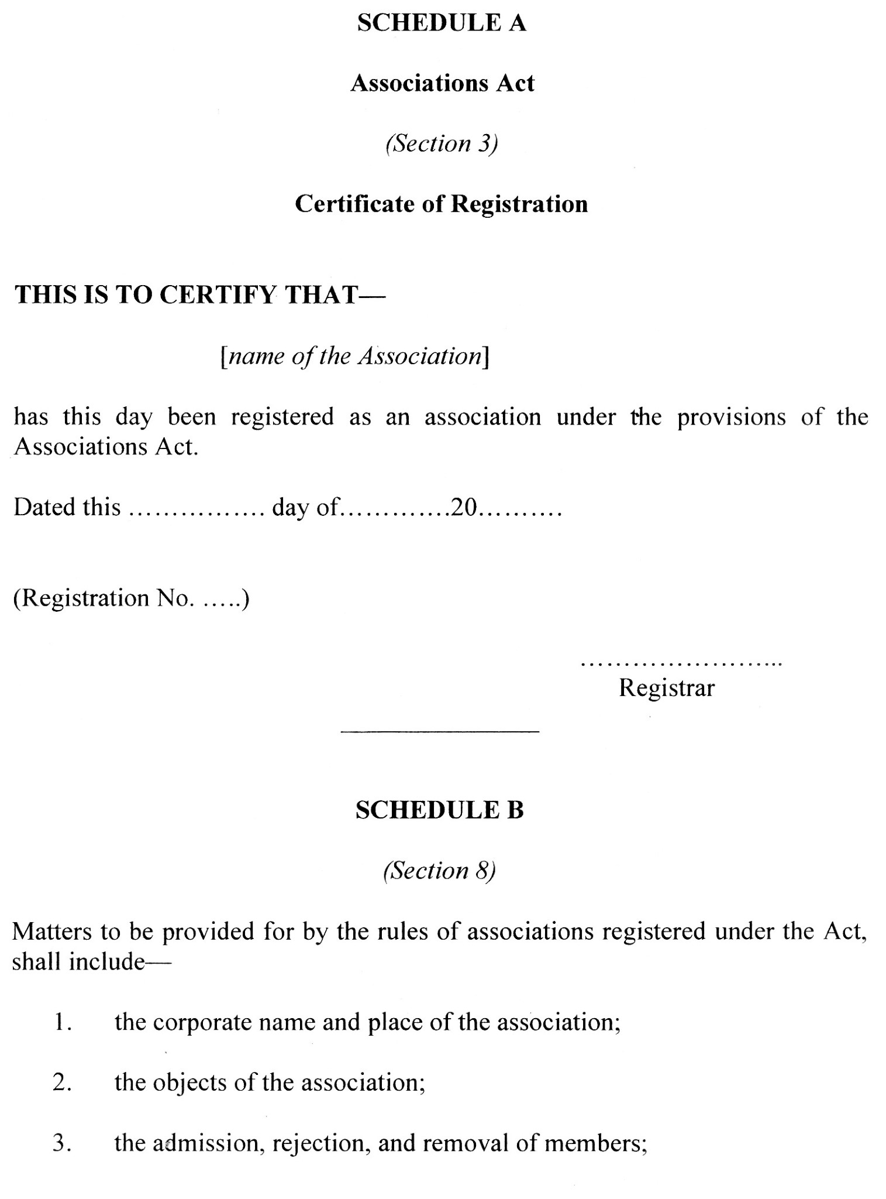

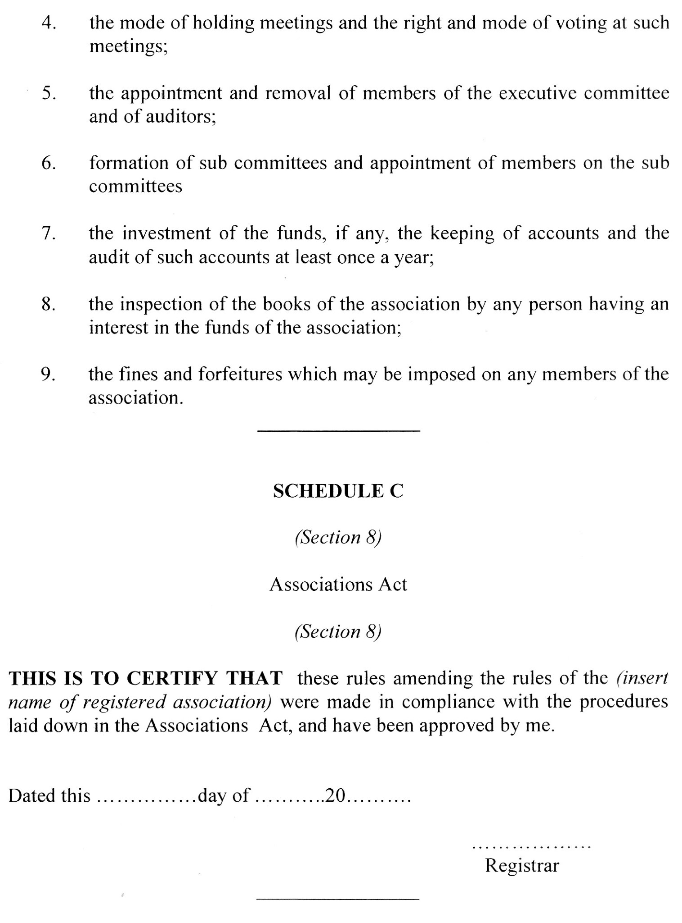

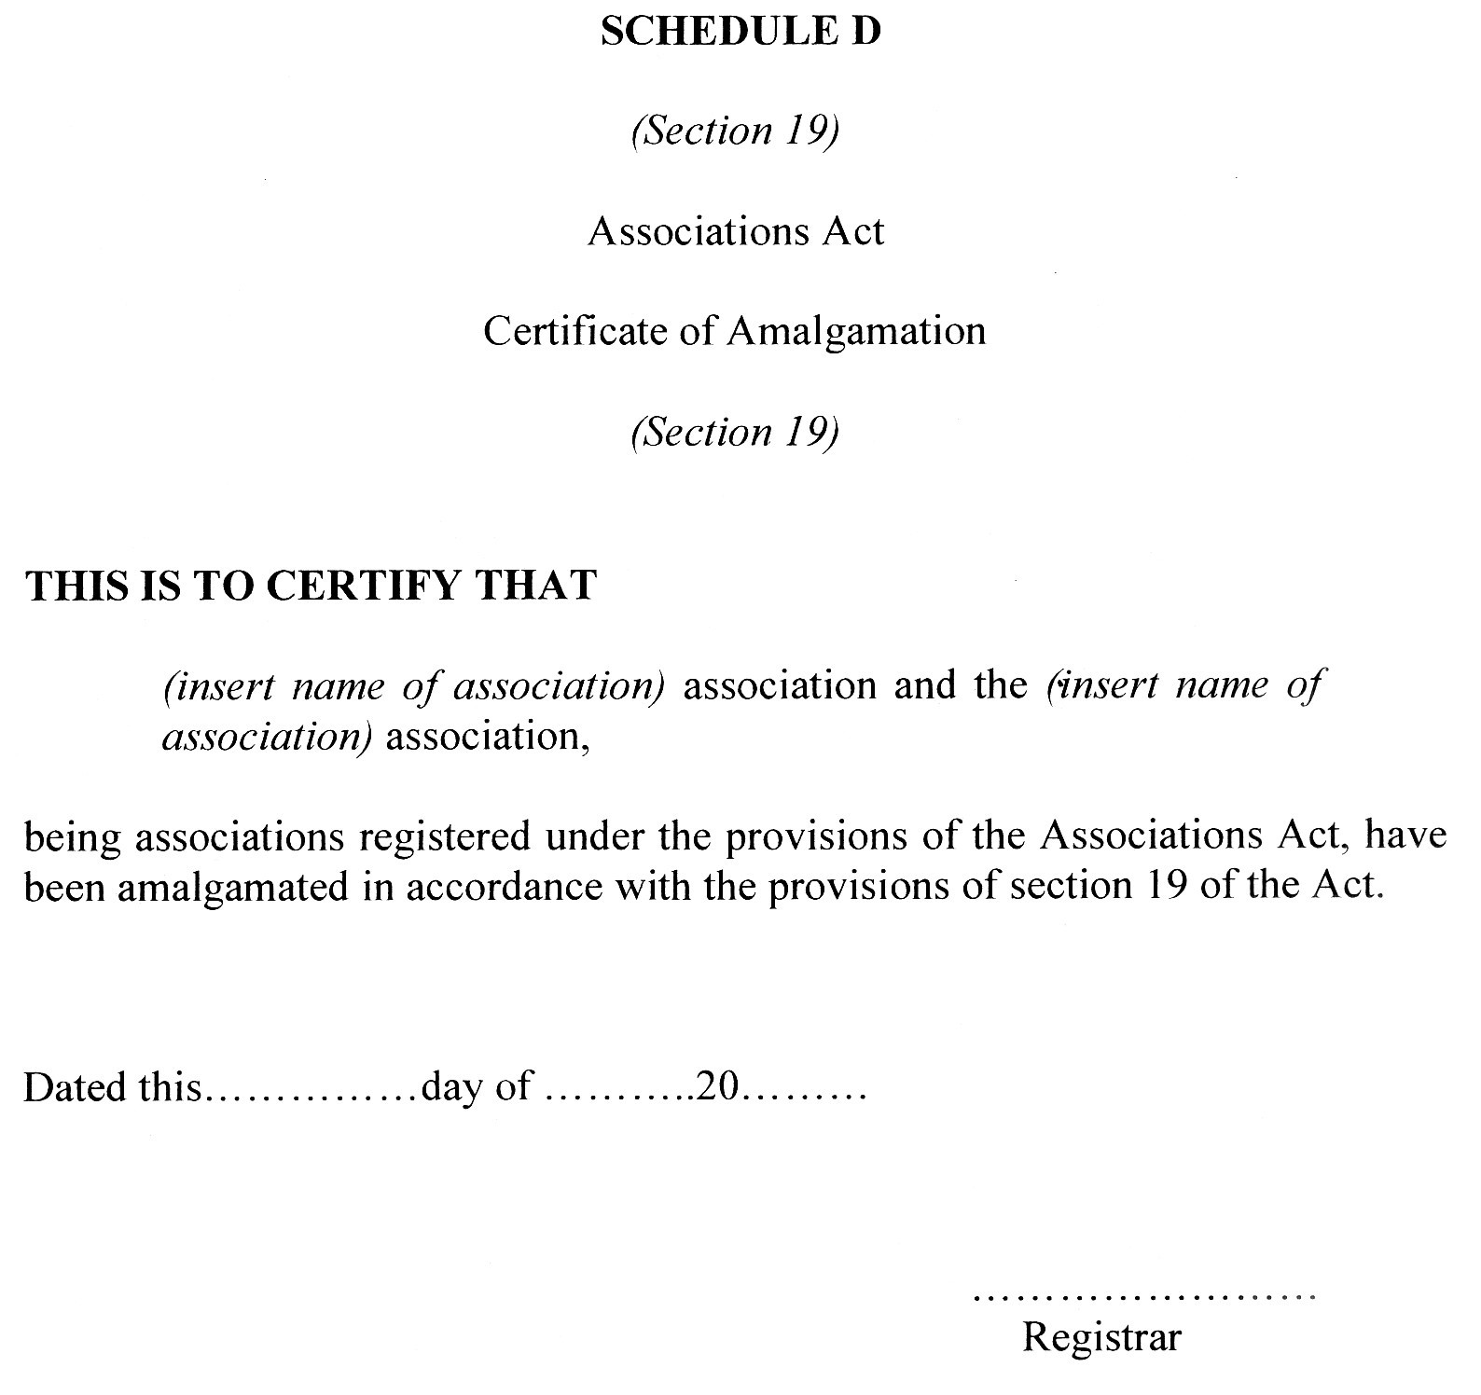

——————

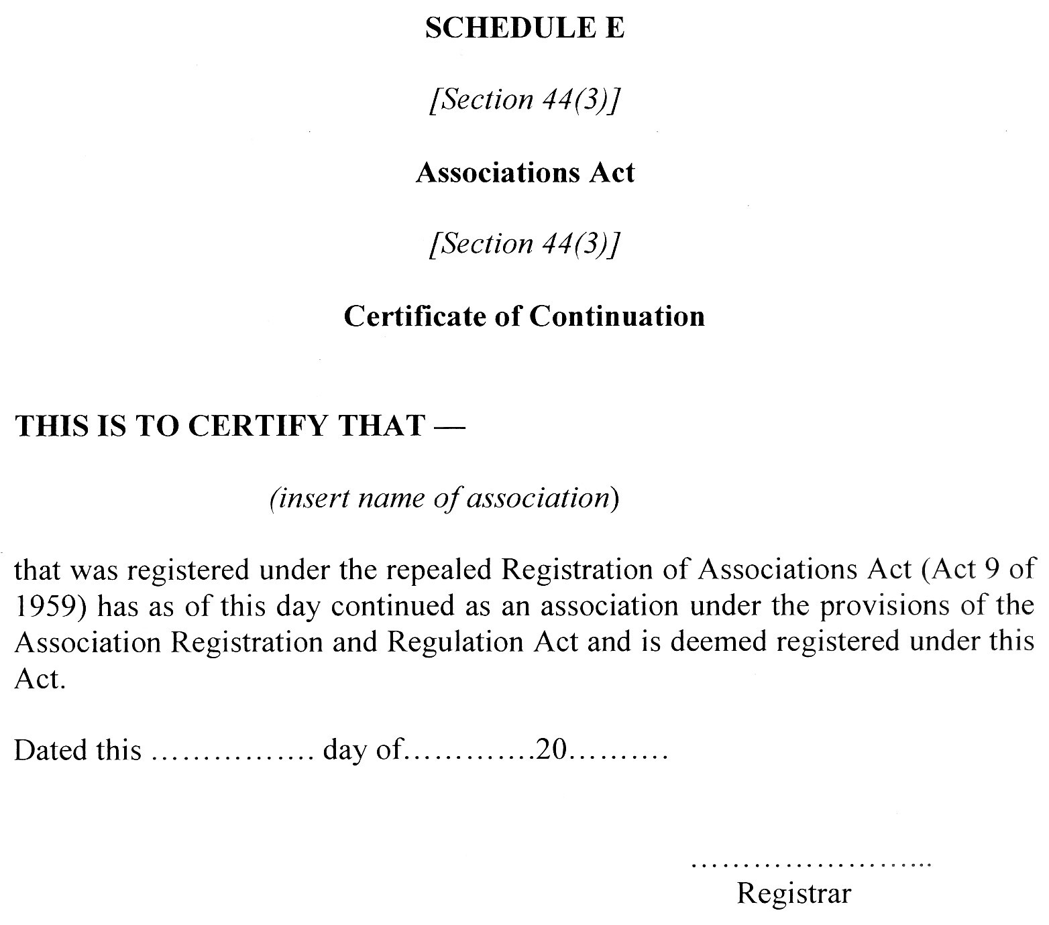

——————

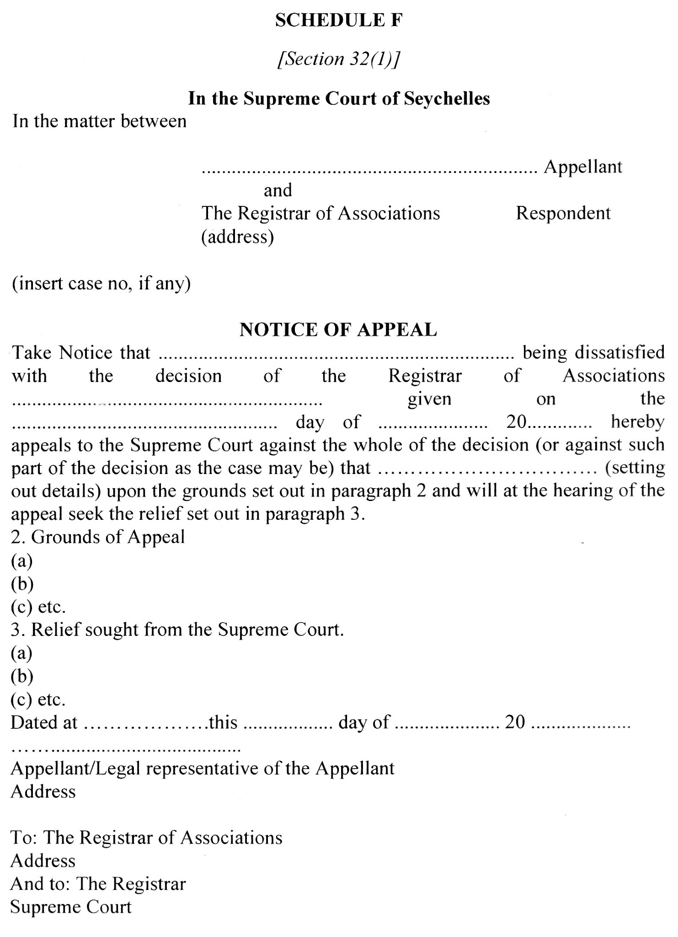

I certify that this is a correct copy of the Bill which was passed by the National Assembly on 6th April, 2022.

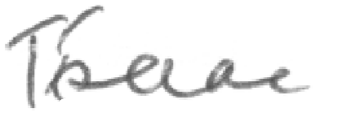

Mrs. Tania Isaac

Clerk to the National Assembly